CA -3

Build & Release Management Laboratory
Submitted by:
Nandana S
12317635
K23DV - A - 07

B-Tech CSE DevOps
GitHub Link: https://github.com/nandanaShaji77/CA-3-DevOps-Automation.git



Task 1: Provisioning & Output Capture
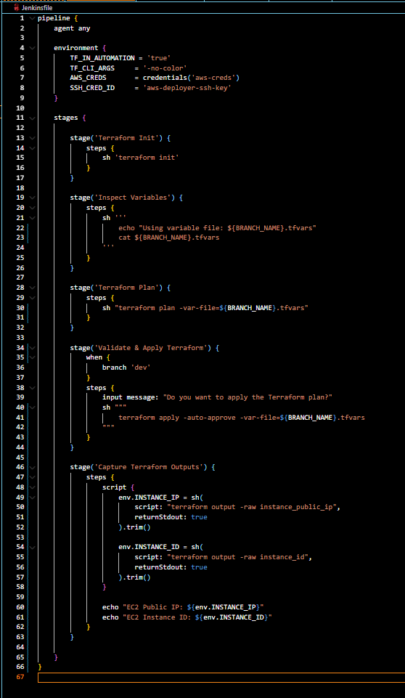
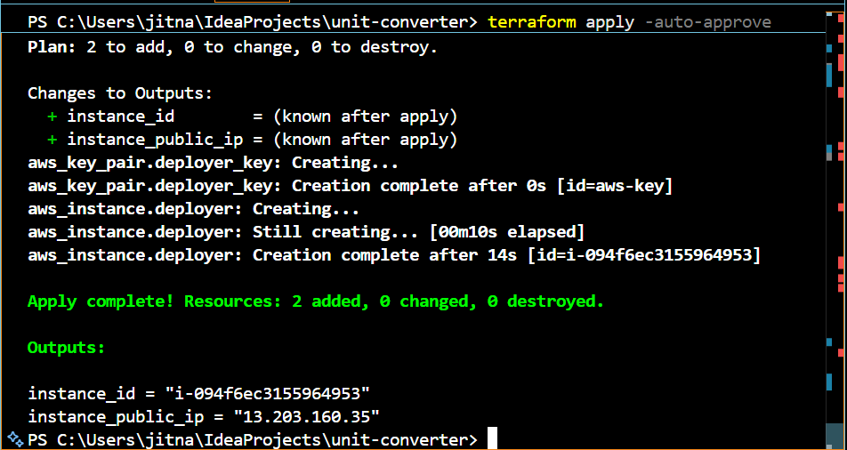

Task 2: Dynamic Inventory Management

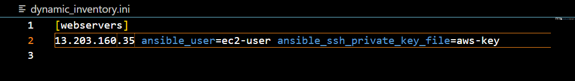
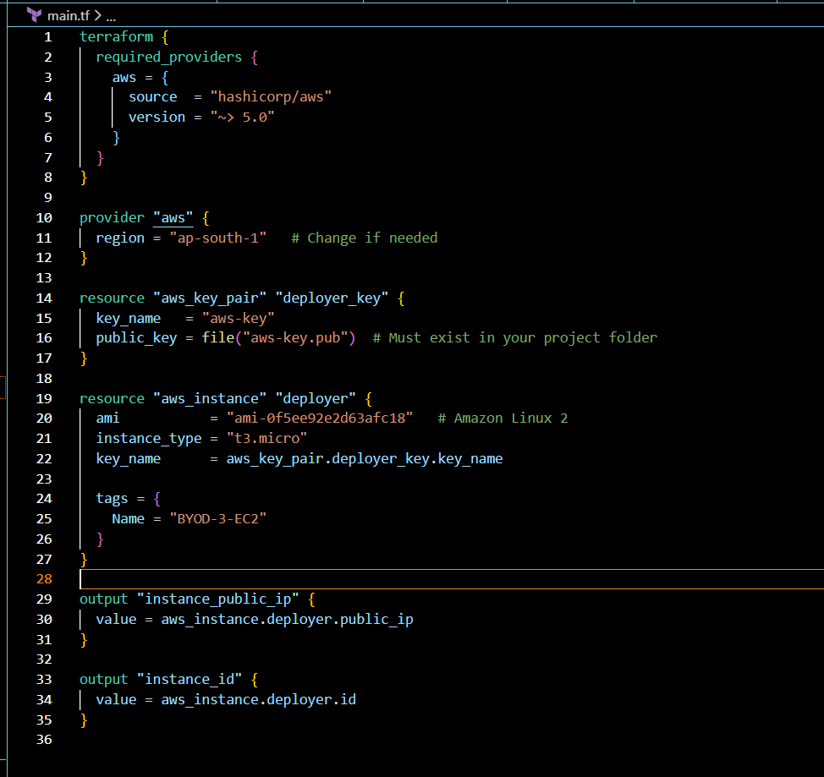
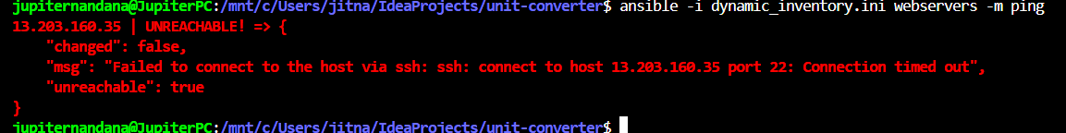
Task 3: AWS Health Status Verification
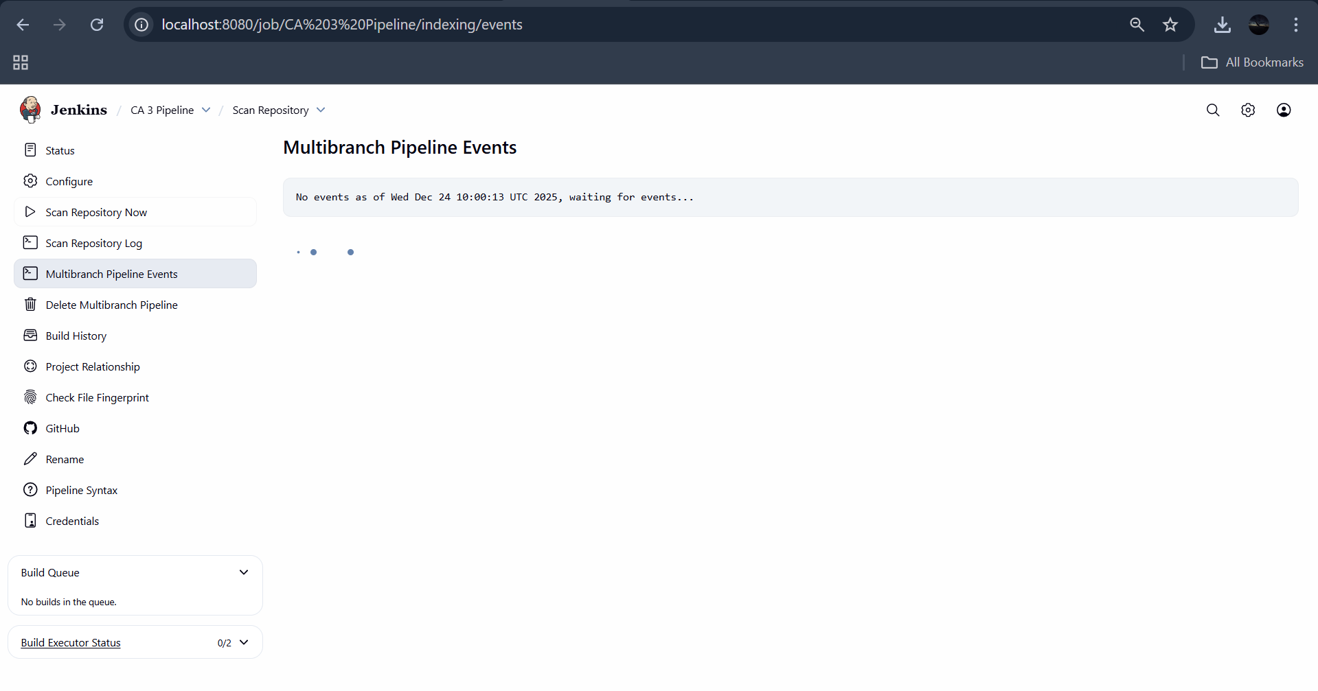
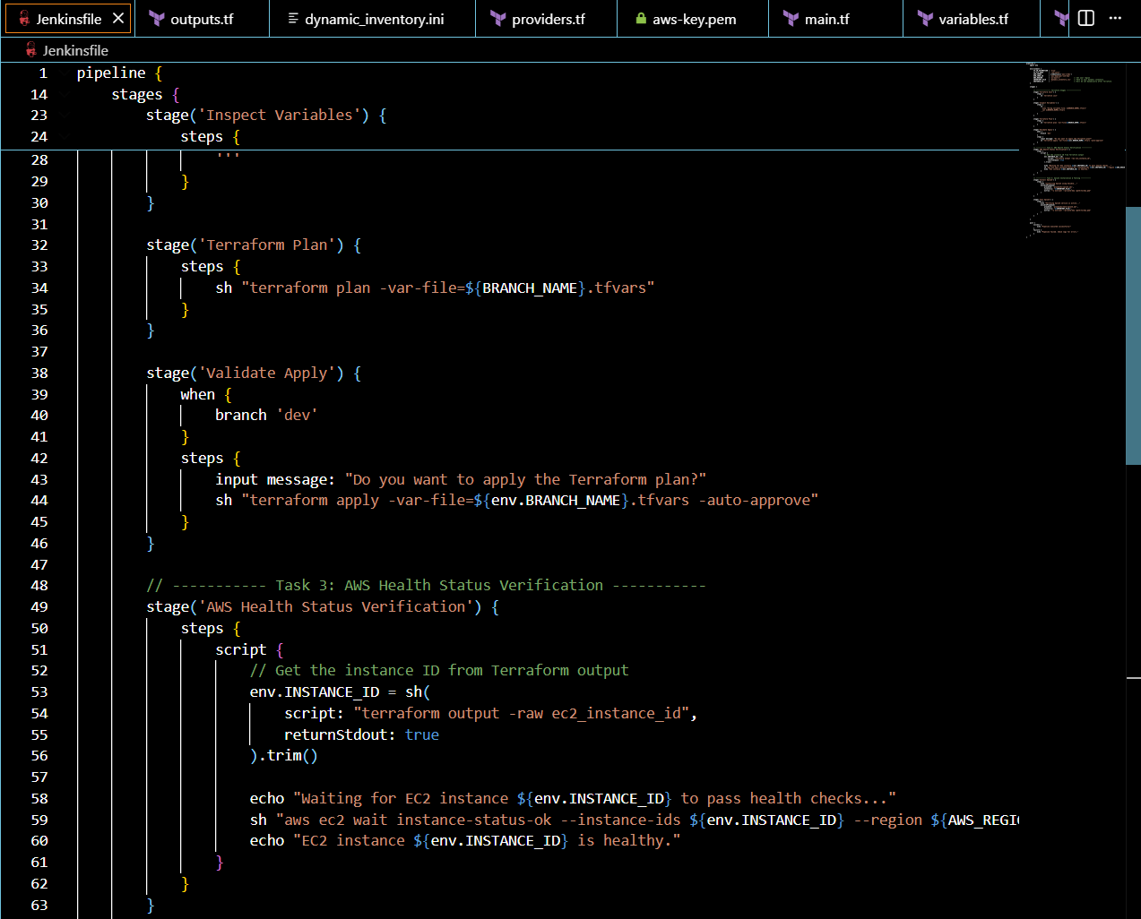
Task 4: Splunk Installation & Testing
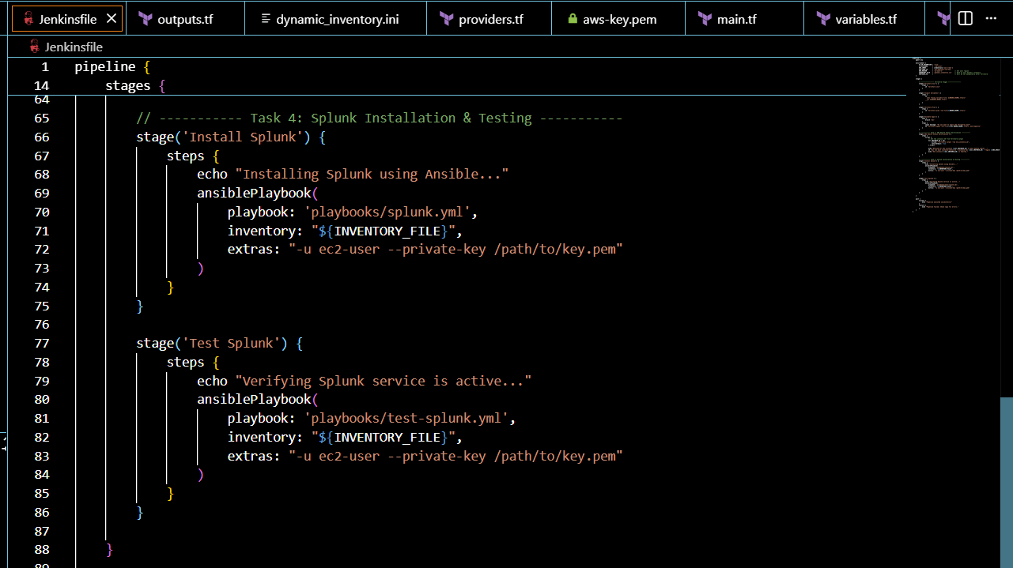

Task 5: Infrastructure Destruction & Post-Build Actions

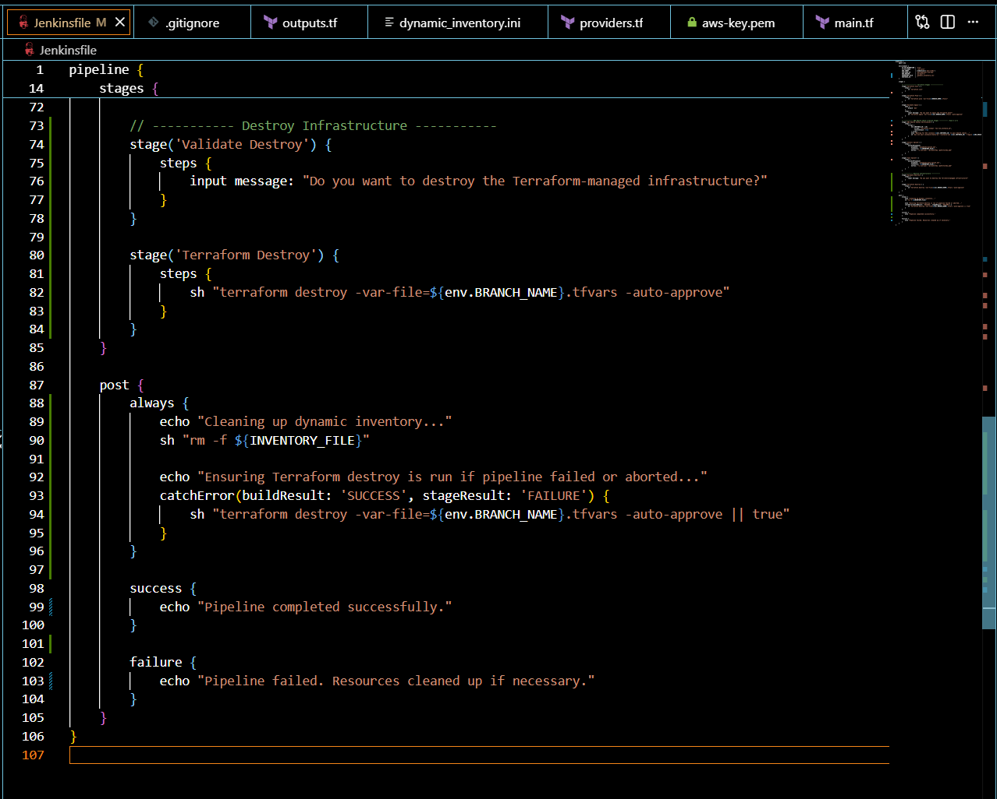

! : git push not working.

